Enable IE mode on Microsoft Edge

- Open Microsoft Edge on Windows 10.
- Click the Settings and More (ellipsis) button on the top-right corner.
- Select the Settings option.
- Click on Default browser.
- Under the “Internet Explorer compatibility” section, turn on the “Allow sites to be reloaded in Internet Explorer mode” toggle switch to enable IE mode in Edge.
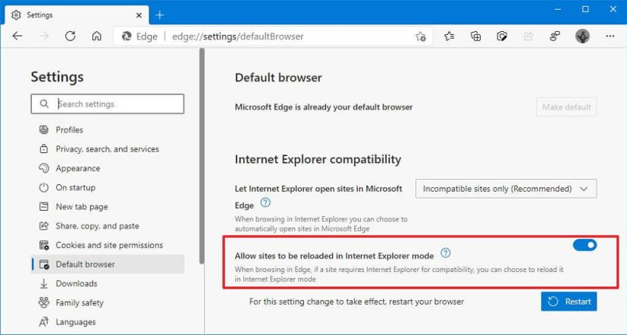
- Click the Restart button.

Once you complete the steps, when sites require Internet Explorer, you can use Microsoft Edge to reload the page using IE mode.

Open Site with IE Mode on Edge

After the IE Mode is enable, you need to reload a page with the compatibility mode manually.

To open an incompatible website with IE Mode on Edge:

- Open Microsoft Edge on Windows 10.
- Click the Settings and More (ellipsis) button on the top-right corner.
- Select the More tools submenu and choose the “Reload in Internet Explorer mode” option.
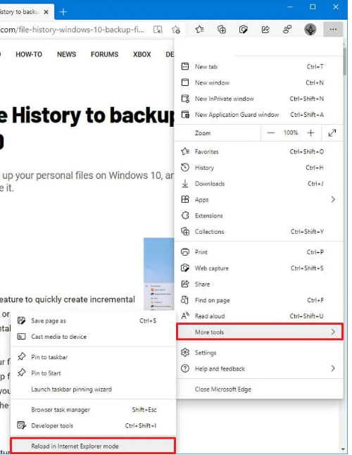

After you complete the steps, the website should reload in compatibility mode. If the feature is not enabled, the option won’t be available in the menu.

If you want to exit IE Mode, you can use the same instructions, but on step #3, select the Exit Internet Explorer mode option.

Open Internet Explorer Sites on Microsoft Edge

To let IE open websites with Edge, use these steps:

- Open Microsoft Edge on Windows 10.
- Click the Settings and More (ellipsis) button on the top-right corner.
- Select the Settings option.
- Click on Default browser.
- Under the “Internet Explorer compatibility” section, use the “Let Internet Explorer open sites in Microsoft Edge” drop-down menu and select the option to handle browsing when using Internet Explorer, including:
- Never – IE will never switch to Edge to load the site.
- Incompatible sites only – IE will still load sites, but websites designed for a modern browser will load in Edge.
- Always – IE will always switch to Edge to load websites.
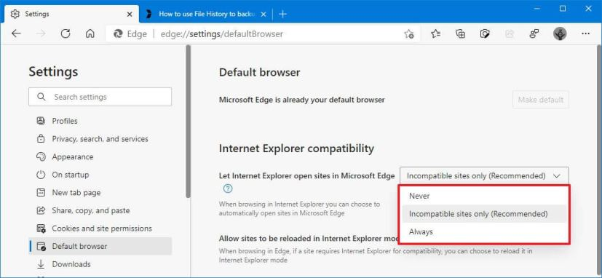

Set the Discover Web Address in Allowed Sites

- Open Microsoft Edge on Windows 10.
- Click the Settings and More (ellipsis) button on the top-right corner.
- Select the Settings option.
- Select Default Browser.
- Click Add under the Allow sites to be reloaded in Internet Explorer mode section.
- Enter https://oradisc1.creighton.edu:8890/discoverer.
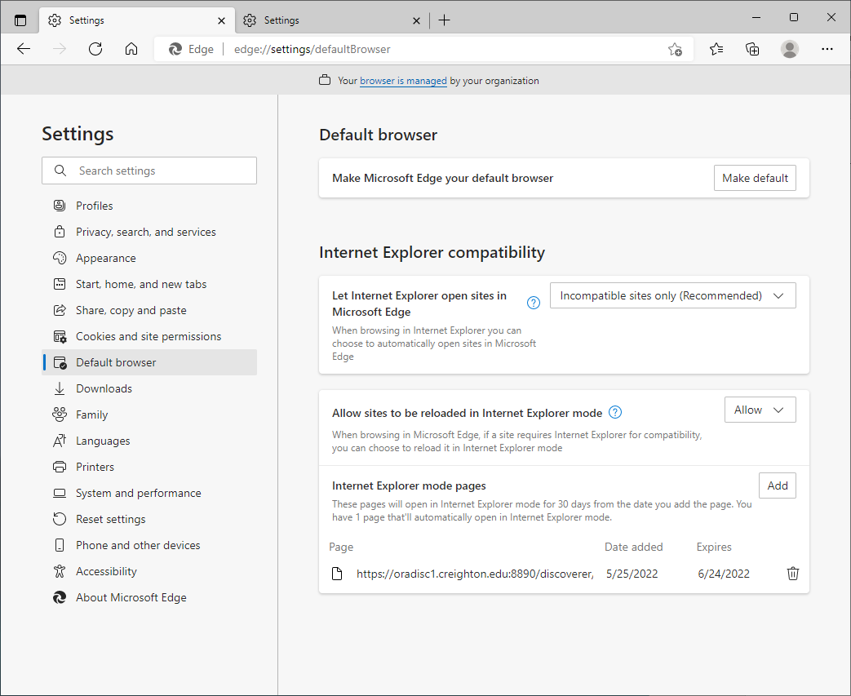

Set the Pop-Up Blocker to Allow Discoverer

- Open Microsoft Edge on Windows 10.
- Click the Settings and More (ellipsis) button on the top-right corner.
- Select the Settings option.
- Select Cookies and site Permissions.
- Click Add under the Allow.
- Enter https://oradisc1.creighton.edu:8890.
